PIZZA SALES SQL QUERIES

- KPI’s
- Total Revenue:
SELECT SUM(total_price) AS Total_Revenue from pizza_sales
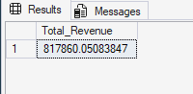

- Average Order Value
SELECT SUM(total_price) / COUNT(DISTINCT order_id) as Avg_Order_Val from pizza_sales
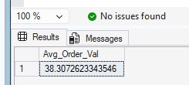

- Total Pizza Sold
SELECT SUM(quantity) As Total_Pizza_Sold from pizza_sales
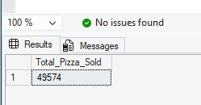

- Total_order
SELECT COUNT(DISTINCT order_id) As Total_Orders from pizza_sales
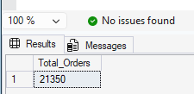
- Average Pizza Per Order
SELECT CAST(CAST(SUM(quantity)AS DECIMAL (10,2))/
CAST(COUNT(DISTINCT order_id) AS DECIMAL(10,2))AS decimal(10,2))As Avg_pizza_per_order from pizza_sales
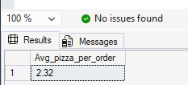

- Daily and Hourly Trend for Total Orders

--DAILY TREND
SELECT DATENAME(DW, order_date) as order_day, COUNT(DISTINCT order_id) as total_orders
from pizza_sales
GROUP BY DATENAME(DW, order_date)

--HOURLY TREND
SELECT DATEPART(HOUR, order_time) as order_hours, COUNT(DISTINCT order_id) as total_orders
from pizza_sales
GROUP BY DATEPART(HOUR, order_time)
ORDER BY DATEPART(HOUR, order_time)

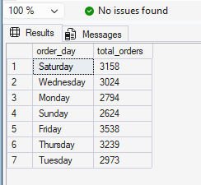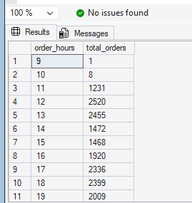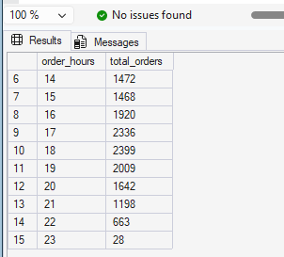

- Percentage of sales by pizza category
SELECT
pizza_category,
SUM(total_price) * 100 / (SELECT SUM(total_price) FROM pizza_sales WHERE MONTH(order_date)=1) AS PCT
FROM pizza_sales
WHERE MONTH(order_date)=1
GROUP BY pizza_category;
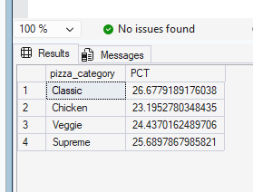

- Percentage of Pizza Sales by Pizza Size
SELECT
pizza_size,
CAST(SUM(total_price) AS DECIMAL(10,2)) AS total_sales,
CAST(SUM(total_price) * 100 /
(SELECT SUM(total_price) FROM pizza_sales WHERE DATEPART(quarter, order_date) = 1)
AS DECIMAL(10,2)) AS PCT
FROM pizza_sales
WHERE DATEPART(quarter, order_date) = 1
GROUP BY pizza_size
ORDER BY PCT DESC
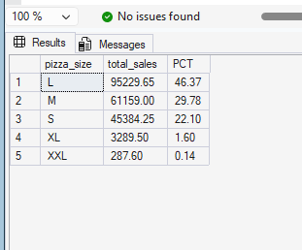

- Total Pizza sold by pizza Catergory
SELECT
pizza_category, sum(quantity) as Total_pizza_sold
from pizza_sales
group by pizza_category
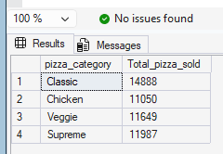

- Top 5 best Sellers by Total Pizza Sold
SELECT top 5
pizza_name, sum(quantity) as Total_Pizza_Sold
from pizza_sales
group by pizza_name
order by sum(quantity) desc
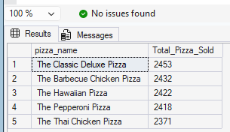

- Bottom 5 worst seller by total pizza sold
SELECT top 5
pizza_name, sum(quantity) as Total_Pizza_Sold
from pizza_sales
group by pizza_name
order by sum(quantity)
